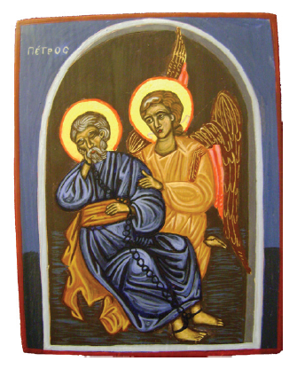

P R A Y E R
G L O B A L D A Y
F O R T H E
P R I S O N M I N I S T R Y
A u g u s t, 25, 2 0 2 0

In 2008, the IPCA Steering Committee chose a special day of prayer in favor of the prison
Ministry. The date chosen was August 25th, the birthday of IPCA.
Every year one of the regions prepare the prayer day program.
The logo, Peter’s release from prison, is especially chosen for IPCA Global Day of prayer.
Jesper Neve from Sweden painted it 2009 and gave IPCA full ownership of the icon.

THE THEME FOR THIS YEAR IS: THE GRACE OF GOD
OPENING PRAYER: Following Lord’s guidance
SONG: Of your choice
PRAYERS:
- Thank God for His grace and mercy upon prison chaplains, prisoners and prison staffs:
Let pray together with a Psalm of David:
Bless the LORD, O my soul; And all that is within me, bless His holy name!
Bless the LORD, O my soul, And forget not all His benefits
Bless the LORD, all His works, In all places of His dominion. Bless the LORD, O my soul!
Bless the LORD, O my soul! O LORD my God, You are very great: You are clothed with honor and majesty— (Psalms 103: 1-2, 22 and 104: 1)

- Prayer of repentance from our daily life:
Let pray together with a Psalm of David:
Who forgives all your iniquities, Who heals all your diseases,
Who redeems your life from destruction, Who crowns you with lovingkindness and tender mercies,
Who satisfies your mouth with good things, So that your youth is renewed like the eagle’s.
The LORD executes righteousness And justice for all who are oppressed.
He made known His ways to Moses, His acts to the children of Israel.
The LORD is merciful and gracious, Slow to anger, and abounding in mercy.
He will not always strive with us, Nor will He keep His anger forever.
He has not dealt with us according to our sins, Nor punished us according to our iniquities.
For as the heavens are high above the earth, So great is His mercy toward those who fear Him;
As far as the east is from the west, So far has He removed our transgressions from us.
As a father pities his children, So the LORD pities those who fear Him.
For He knows our frame; He remembers that we are dust.
As for man, his days are like grass; As a flower of the field, so he flourishes.
For the wind passes over it, and it is gone, And its place remembers it no more.
But the mercy of the LORD is from everlasting to everlasting On those who fear Him, And His righteousness to children’s children,
To such as keep His covenant, And to those who remember His commandments to do them.
The LORD has established His throne in heaven, And His kingdom rules over all. (Psalms 103: 3-19)

- Asking the guidance from God by the Holy Spirit. And when they had prayed, the place where they were assembled together was shaken; and they were all filled with the Holy Spirit, and they spoke the word of God with boldness. (Acts 4: 31)

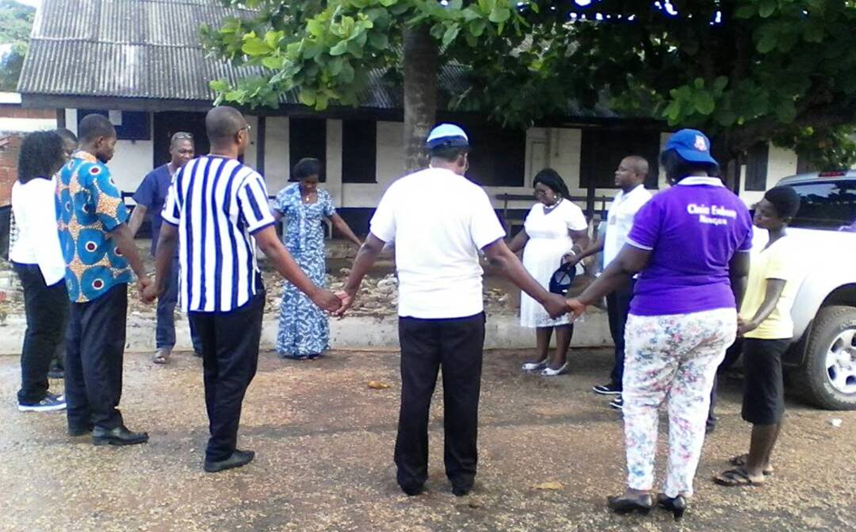

Reading Scriptures: 1 Corinthians 15: 10; Exodus 33: 19 and Titus 2: 11.
From the Scriptures:
Thank God for His grace, all we are and all we have, we got it from His grace. Even the protection during this pandemic, we got it from Him.
Prisoners are protected from His grace, prison officers; ourselves as prison chaplains we are protected by Him from His grace in Jesus name.
Our lives today, are the board showing His grace upon us.
Our wife, our husbands, our children are the image showing His grace upon us.
As some of countries prison chaplains can enter the prison to serve the Lord with prisoners, we are making it through His grace.
It only by His grace that we are prison chaplains, only by His grace that every day we can enter the prison gates and go back to our house.
He is helping us by that grace and we can say thank you God by His grace.
We can communicate again after ones and others during this pandemic because of His grace.
His grace in Jesus name is all we have.
His goodness is in front of us.
We are the privileged and blessed people to benefit His mercy among the nations.
We are sinners, but His mercy in Jesus name is what makes our life safe and fruitful and because of Jesus work on the cross we are forgiven from our sins.
Can we say thank you Lord for your grace and mercy upon our families, upon prison officers, upon prisoners during this pandemic?
Yes!
Because without His mercy, our gathering today was not possible but by His grace and mercy we are gathering today in front of Him, to say thank you Lord!
For the grace of God has appeared to offers salvation to all people.
We are saved and can say thank you Lord by His grace in Jesus-Christ name,
Amen!
LET US PRAY:
Our Father in heaven, Hallowed be Your name.
Your kingdom come. Your will be done On earth as it is in heaven.
Give us this day our daily bread.
And forgive us our debts, As we forgive our debtors.
And do not lead us into temptation, But deliver us from the evil one. For Yours is the kingdom and the power and the glory forever.
Amen.
SONG: Of your choice
PRAYER REQUESTS:

- For the families affected with the pandemic or has loosed their loved ones.

- For the health, security and peace to the inmates, prison officers and prison chaplains.

- For those suffering for the luck of foods, cloths, Bibles and good dormitory.

- For the Worldwide Steering Committee and our regions.

- Our local prayer requests.
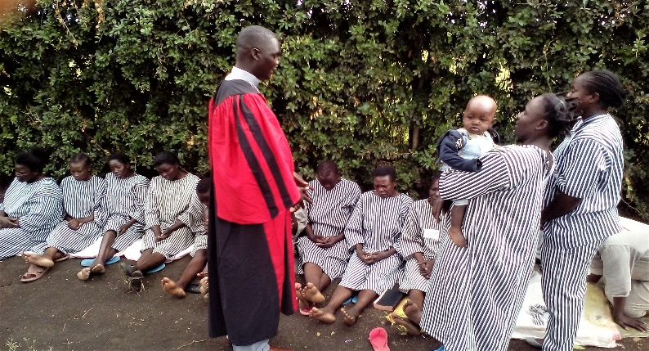

PRAYER OF BENEDICTION
Amen.
SHORT IPCA PRESENTATION:
The International Prisons Chaplains’ Association (IPCA) helps Prison Chaplains everywhere to be in touch with each other to be more effective in their ministry. It aims to support all chaplains regardless of race, gender and religion.
IPCA recognizes that the enclosed institutional life of prison chaplains can isolate them from their churches. IPCA therefore works towards helping prison chaplains globally make supportive contacts to enhance their care for prisoners and their affirmation of the inherent dignity of every individual held in custody.
IPCA creates links with churches and challenges them and their congregations to take the ministry to prisoners more seriously. IPCA invites the churches to offer the necessary support to chaplains in their ministry to prisoners and also to prison staff.
As an Organisation in Consultative Status with United Nations: IPCA is committed to implementing peace and justice and affirms the obligations for all countries to adopt all the standards recommended by the United Nations.
For the last ten years the IPCA Steering Committee has invited all those involved in prison ministry around the world to come together in a special day of prayer on 25 August, the birthday of IPCA. We would like to thank members of IPCA AFRICA and EUROPE for arranging this year’s program together.

